GIT and GITHUB -01

git init helps to create empty .git directory and that directory will have all the configuration tools regarding the git tool.
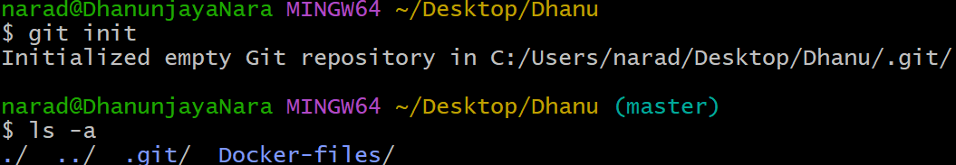

git status to track the changes in the repository.
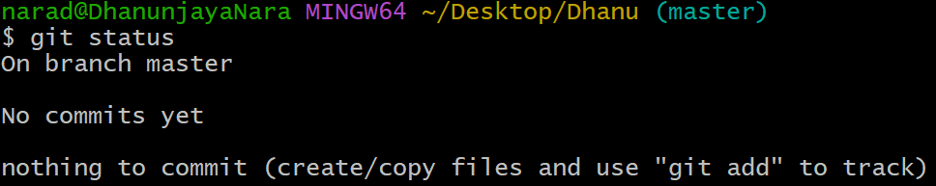
git config --list to get all the details like username and all which are very important to push anything to central repository.
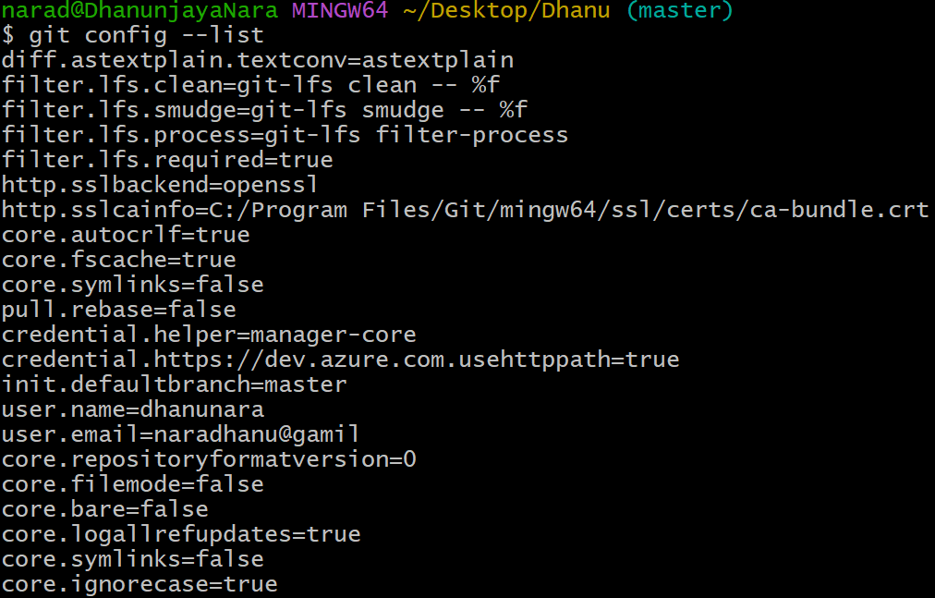

git config --global user.name “username” to add the username.
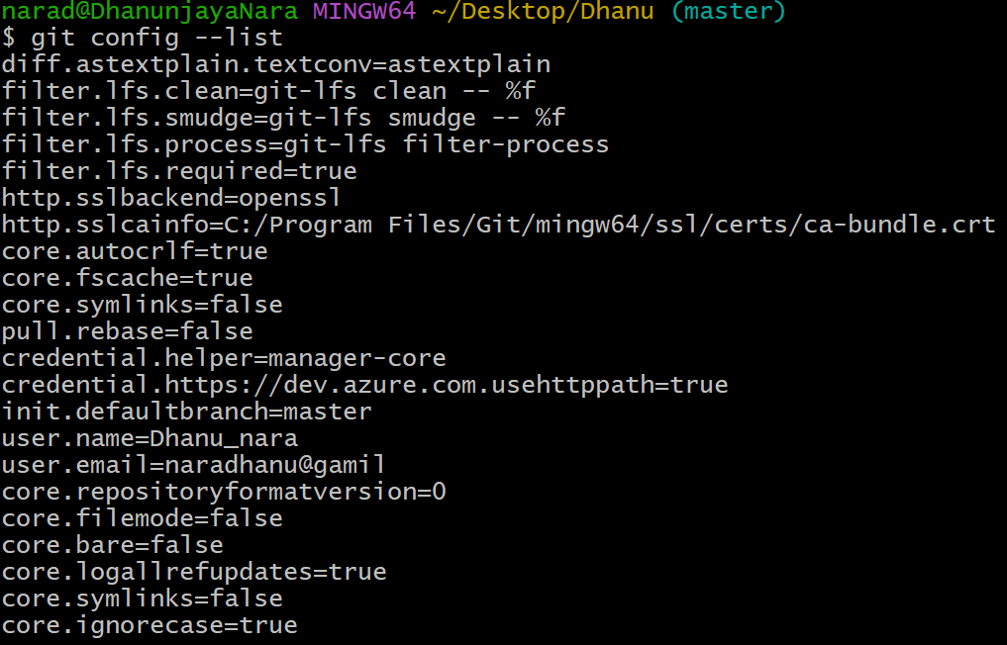

git config --global user.name “usermail” to add the usermail.
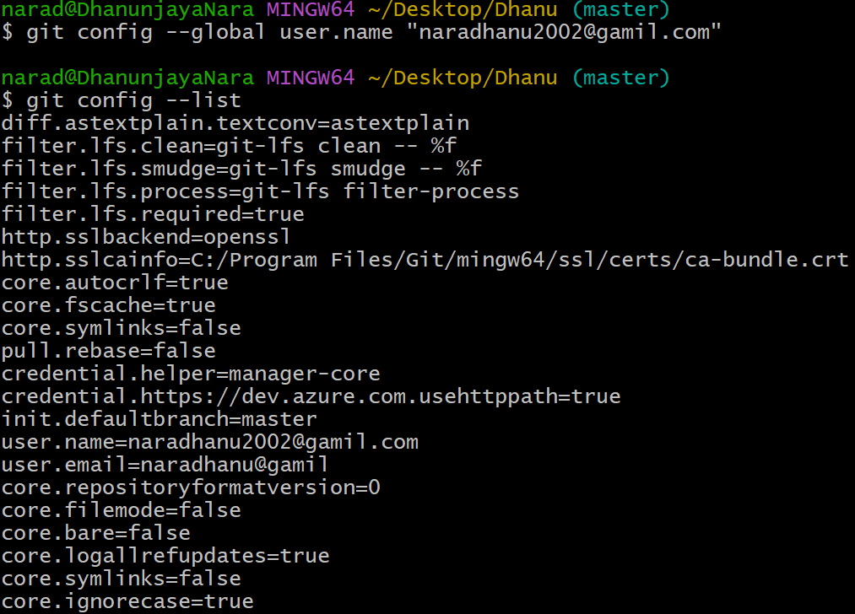

git add to track the untracked ones.
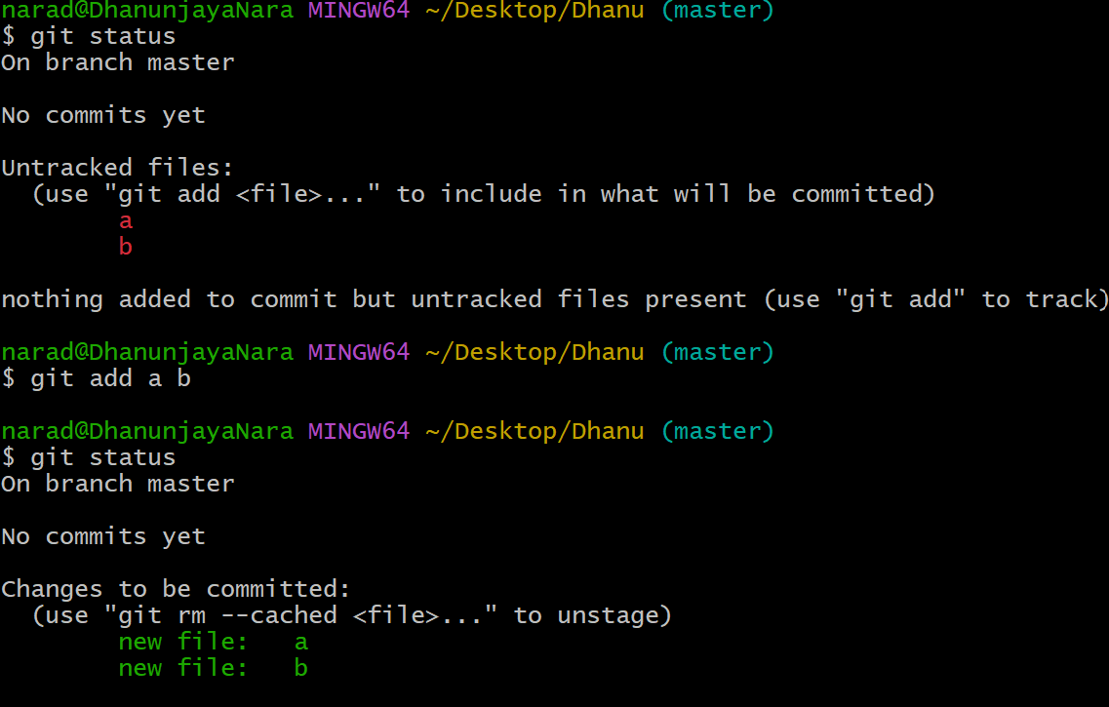

git . to track all the files at a time
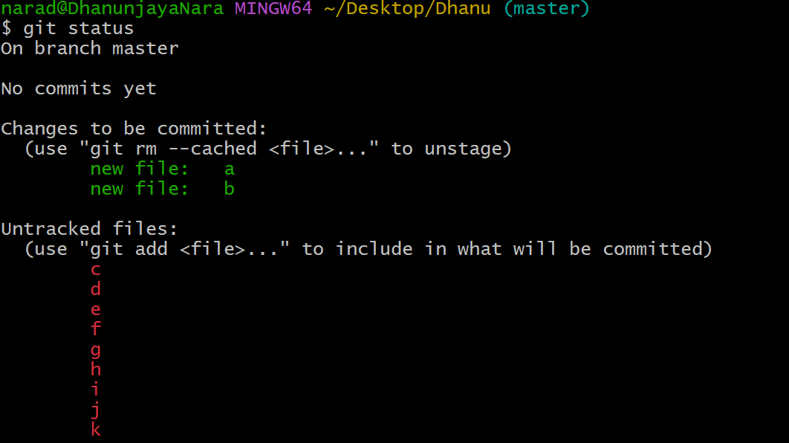
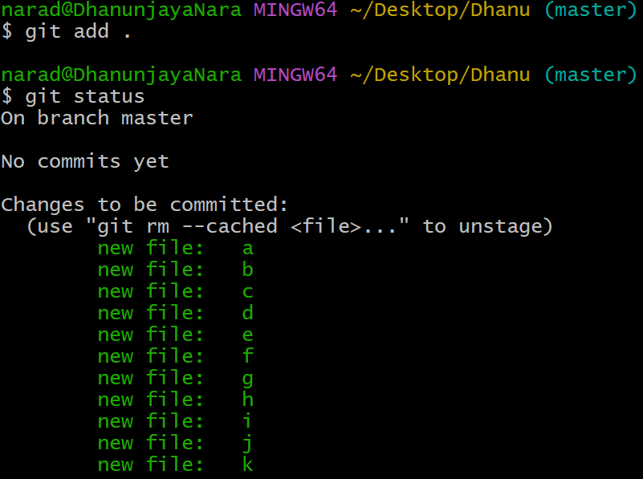

git commit -m “commit message” which will be use to understand the changes in the code. And after doing this only code will be ready to push into central repository.
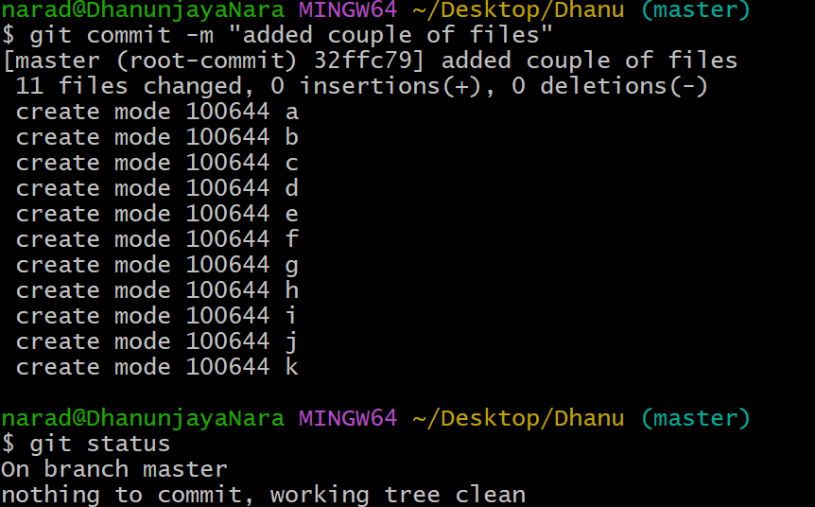

git log enables to see the changes made and all will be stored even the commit id also.
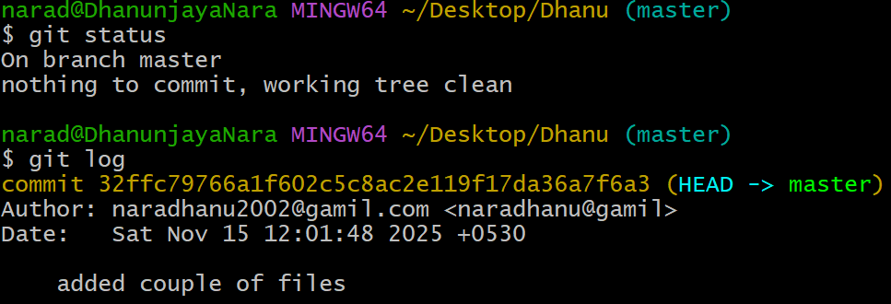

remote -v to check any address is configured or not.
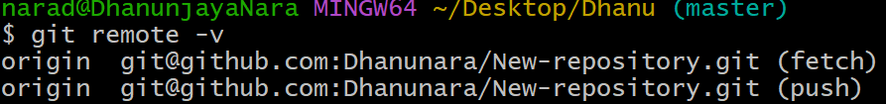

ssh-keygen which will be used to generate key and that will be used to connect to the central repository.
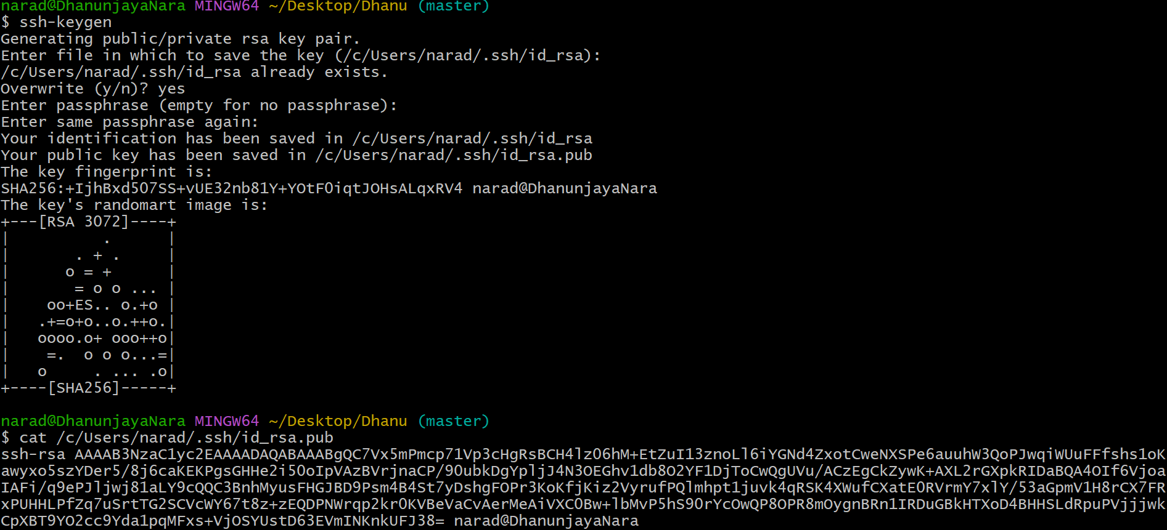

git push -u origin will be used to push source code from local machine to central repository.
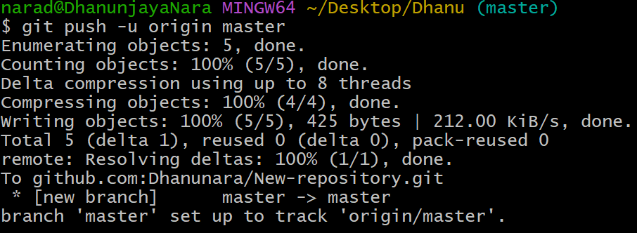

git pull is used to get the file from central repository to local machine.
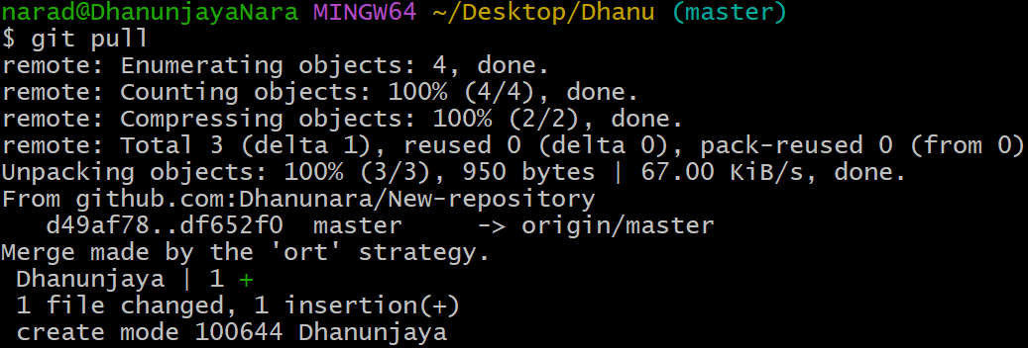

git clone will be used to download the source code from central repository to local repository . we use git cone and paste the ssh code, which will replicate all the files of central repository in local machine.
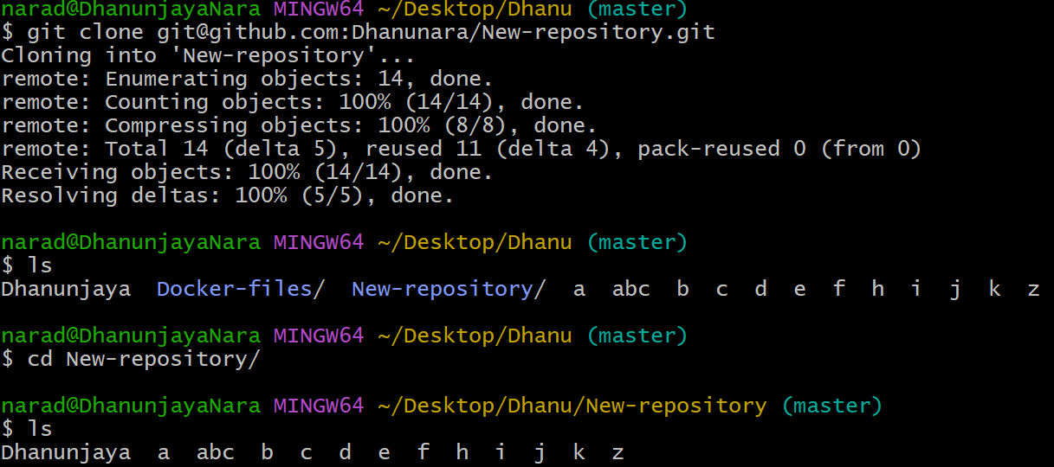

GIT HUB account
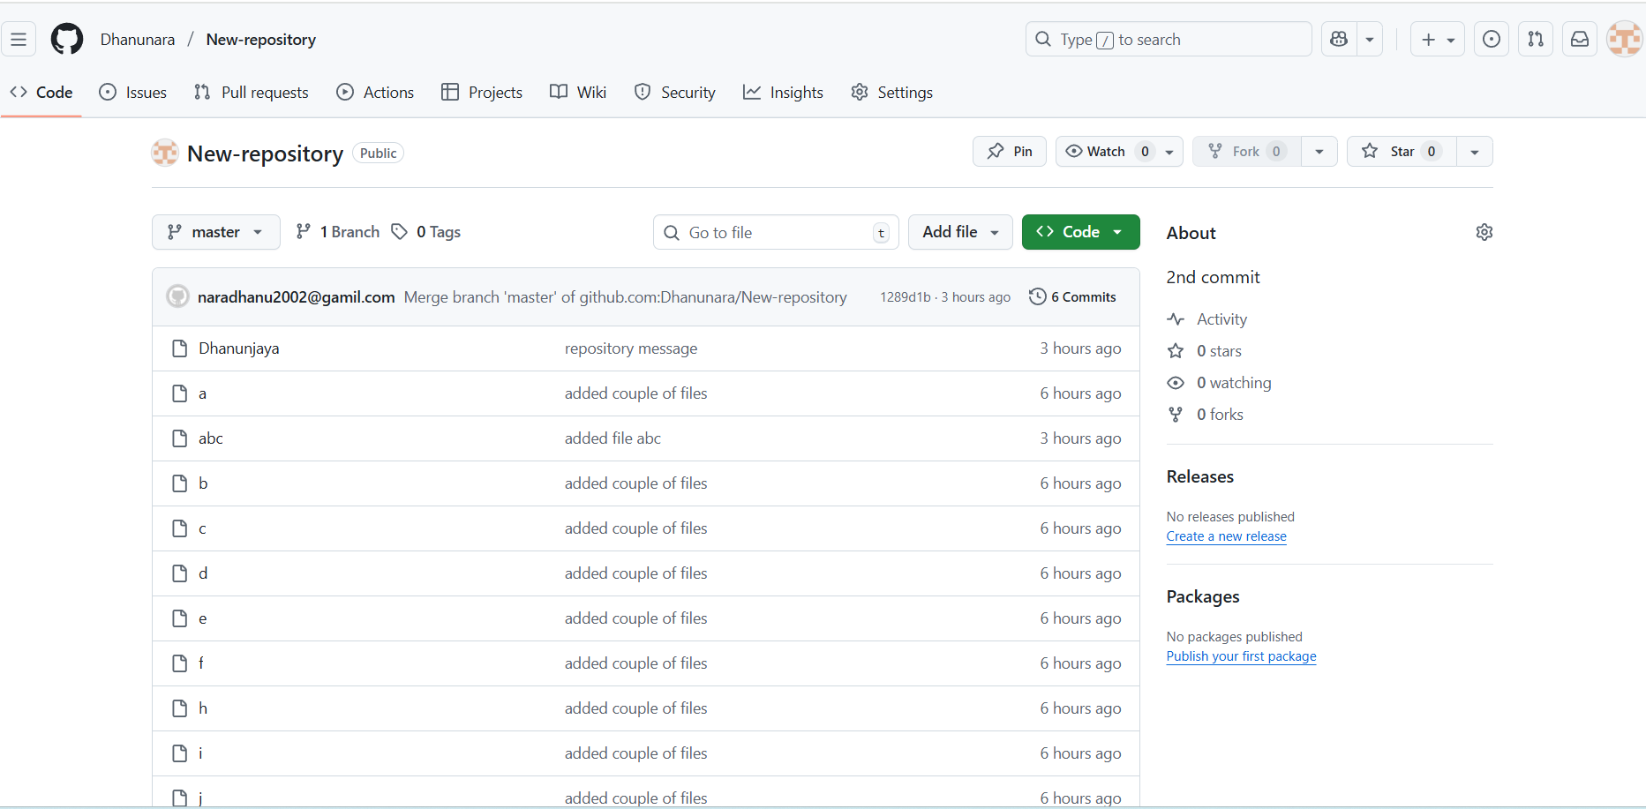

Set up MFA (Multi-Factor Authentication) for the GITHUB account using a mobile app.
